Sierra Rossman

October 24, 2022

CS 255U

Assignment 7

Chapter 33

5. Write a shell script named private that uses chmod to change the access permissions on a file so that only the owner may read, write, or execute it. Be sure to label the output to show what was done to the file.

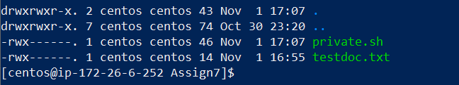

6. Write a shell script named public that reverses the effects of the private script you wrote in the previous exercise.

7. Modify the del script so that it detects whether the user has specified a directory to be deleted, in which case the script should call the rmdir comman:qd.



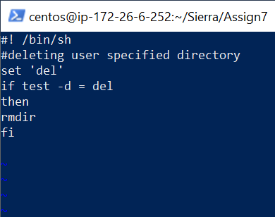

10. The standard echo command echoes its arguments just once. Write a script echo.by that echoes its arguments as many times as the user chooses.

